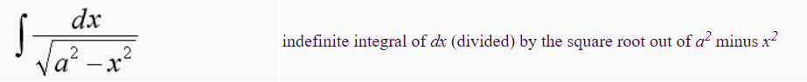

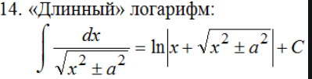equals to logarithm natural of absolute value of open parentheses x plus square root of open parentheses x squared + a squared parentheses parentheses plus constant

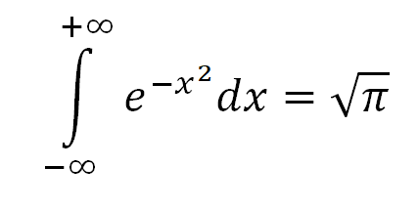 integral from -infinity to +infinity from e to the power of –x squared differential of x is equal to the square root of pi

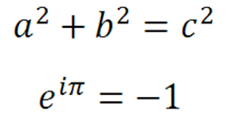a to the power of 2 plus b to the power of is equal to c to the power of 2

e to the power of product of i and pi is equal to minus 1

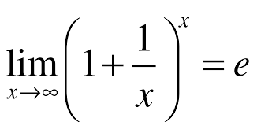 limit of 1 plus 1 devided by x quantity to the power of x as x tends to infinity is equal to e

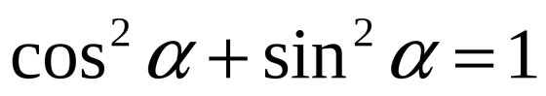 - cosine to the power of 2 alpha plus sine to the power of 2 alpha is equal to 1

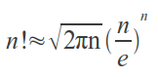 N factorial approximately equal square root of open parentheses product of twice pie and N parentheses multiplied by open parentheses N devided by eulers number parentheses to the power of N

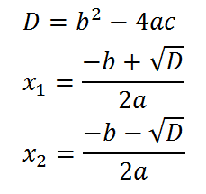 D is equal to b to the power of two minus 4 multiplied by a multiplied by c

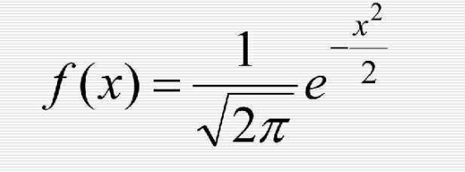 function of x equals to open parentheses eulers number to the power of x squared devided by -2 parentheses devided by square root of twice pie

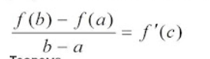

Derivative of function of C equals to open parentheses function of a minus function of b parentheses devided by open parentheses a – b parentheses